Github Actions Certification

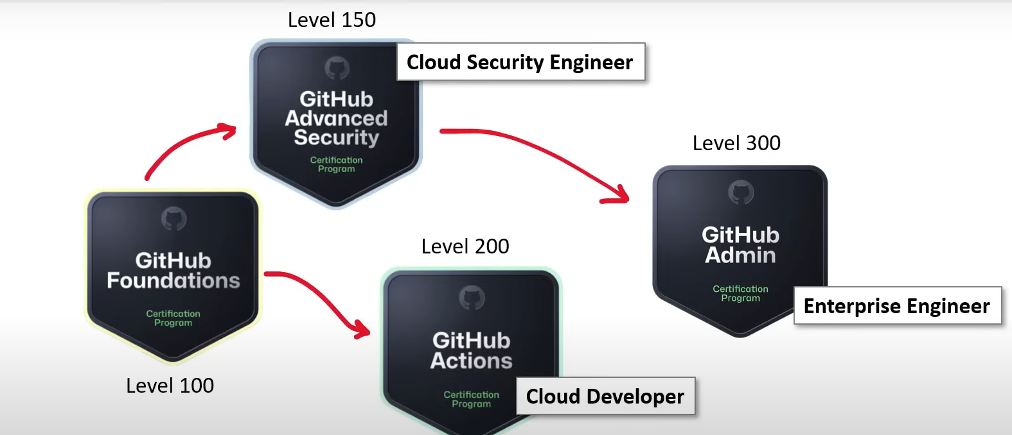

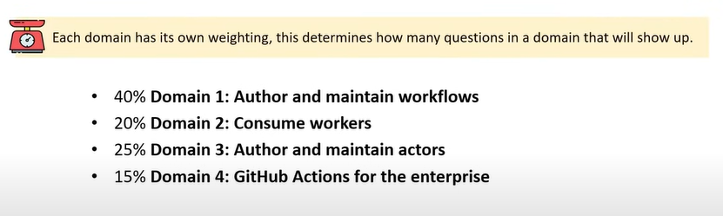

* GitHub Actions is a continuous integration and continuous delivery (CI/CD) platform that allows you to automate your build, test, and deployment pipeline. You can create workflows that build and test every pull request to your repository, or deploy merged pull requests to production.
* GitHub Actions is a continuous integration and continuous delivery (CI/CD) platform that allows you to automate your build, test, and deployment pipeline. You can create workflows that build and test every pull request to your repository, or deploy merged pull requests to production.
* GitHub provides Linux, Windows, and macOS virtual machines to run your workflows, or you can host your own self-hosted runners in your own data center or cloud infrastructure.

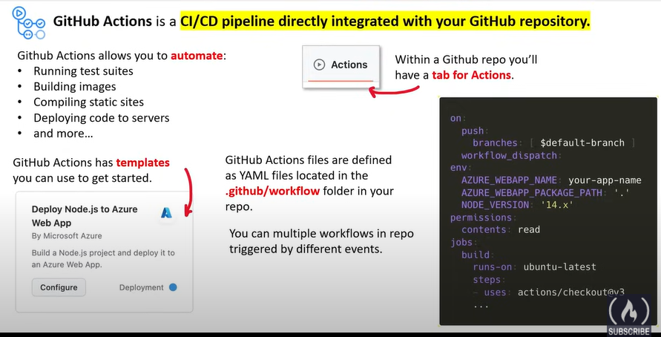

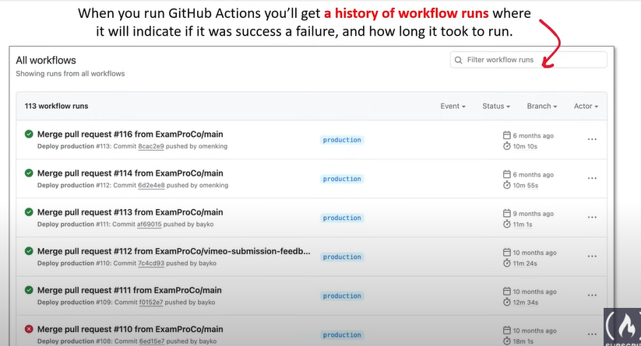

branch_protection_rule

check_run

check_suite

create

delete

deployment

deployment_status

discussion

discussion_comment

fork

gollum

issue_comment

issues

label

merge_group

milestone

page_build

public

pull_request

pull_request_comment (use issue_comment)

pull_request_review

pull_request_review_comment

pull_request_target

push

registry_package

release

repository_dispatch

schedule

status

watch

workflow_call

workflow_dispatch

workflow_run